Program#1

Write a program to find the average of n numbers using arrays.

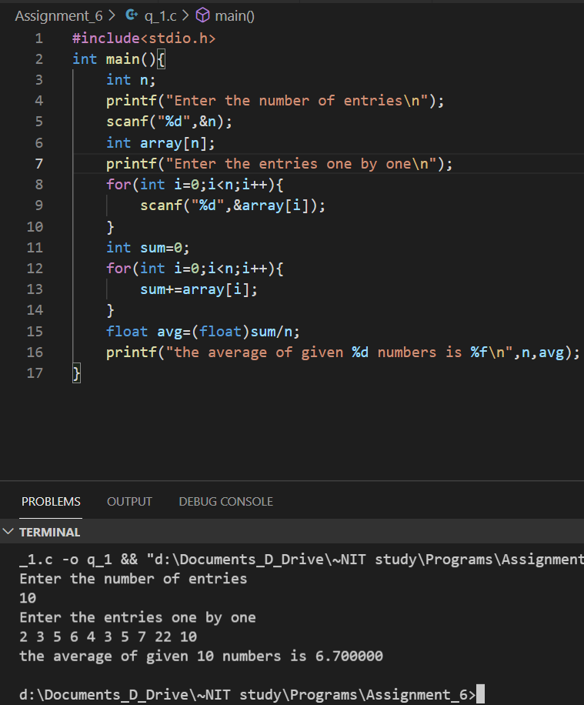

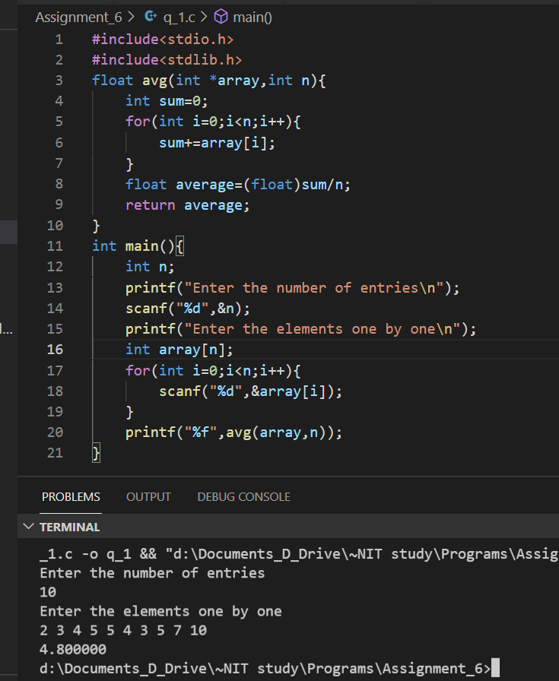

Program#2

1. Write a program to find the average of n numbers using arrays, by passing the array to the function.

.

Program#3

1. Use 2D- arrays to store 3 subject marks of 6 students, and find the average marks of each student and also average marks of each subject.

.

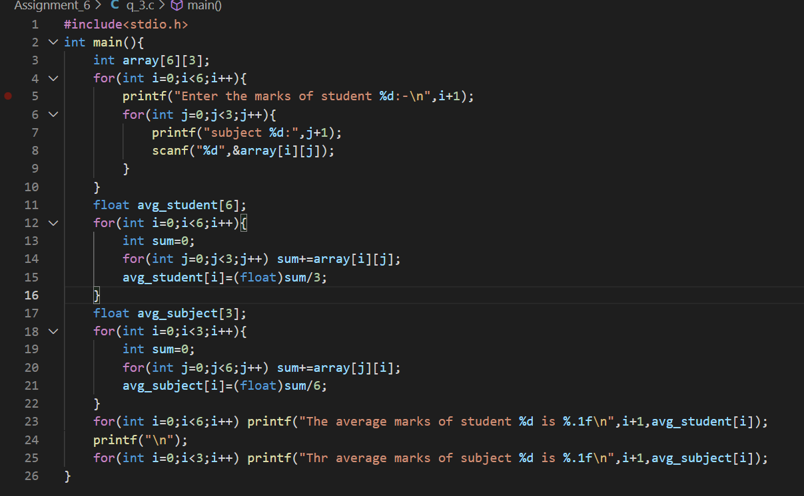

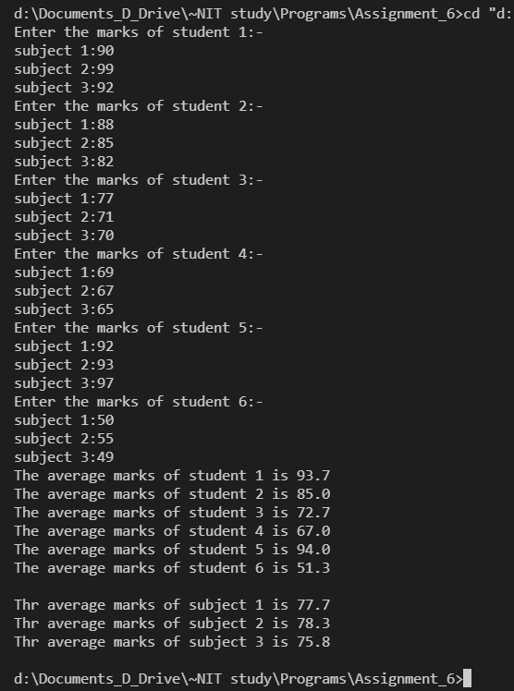

Program#4

1. Find if a given element is present in an integer array using linear search.

.

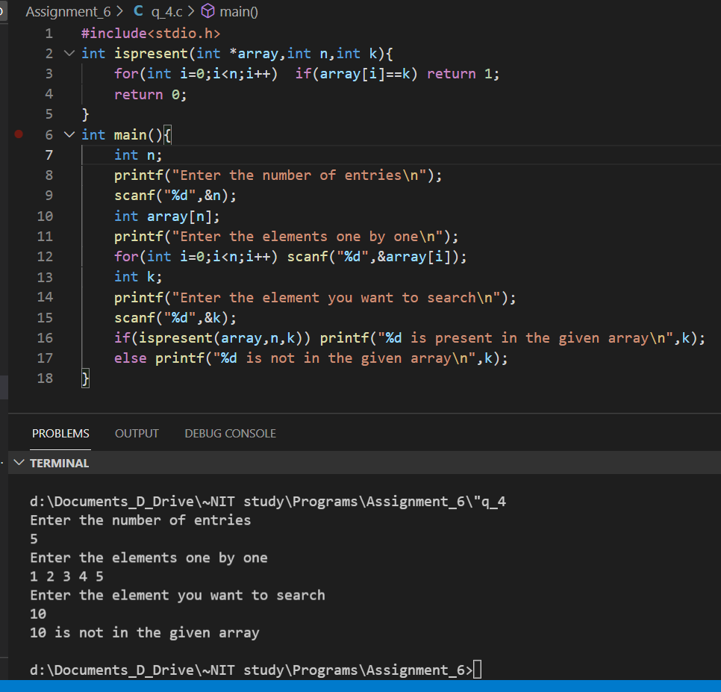

Program#5

5. Write a program to store a character string and display on screen.

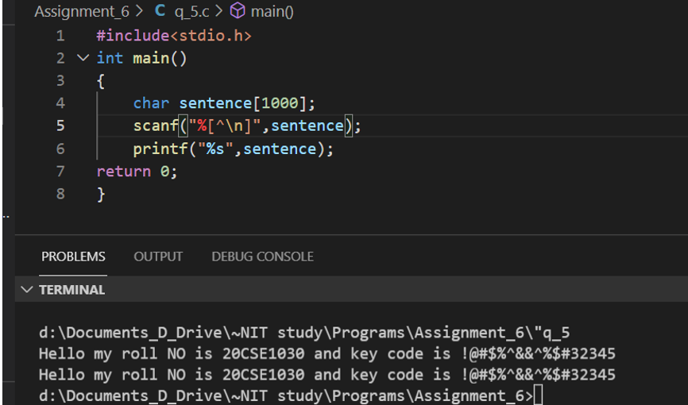

Program#5

1. Write a program to check if a given character is present in a string.

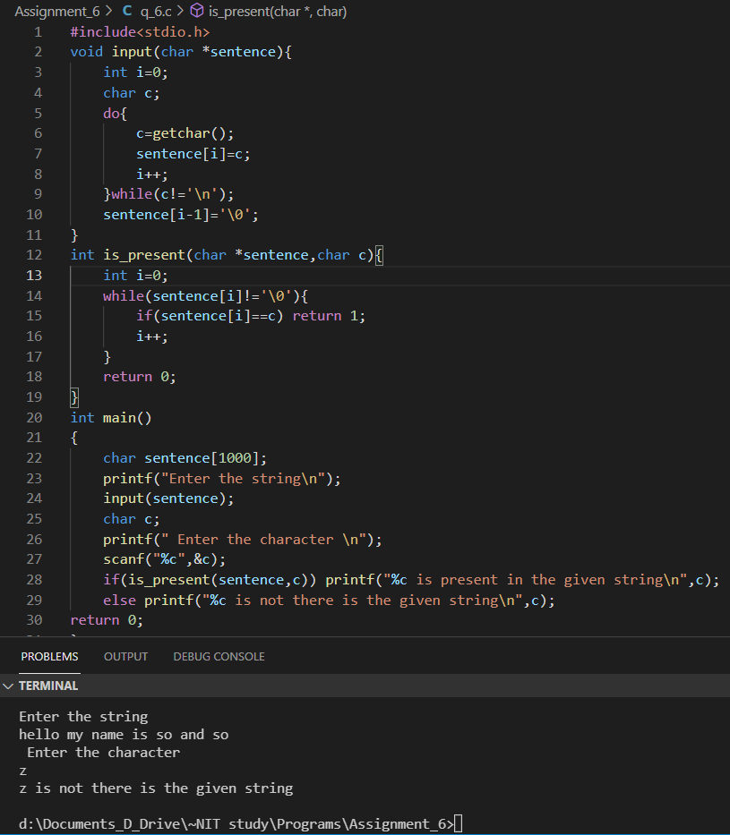

Program#5

8. Write a program to count the number of vowels and consonants in a string

